COMPLIANCE REVIEW — INTERNAL
Mobile Wireframes vs. FRD & Proposal
AI-Powered Property Management & Services Platform
DATE  31 August 2026 | SCOPE REVIEWED  Mobile app wireframes — 11 sections, ~60 screens | COMPARED AGAINST  FRD & Proposal (Mobile Application)

VERDICT
Substantially aligned — sections trace 1:1, five items flagged.
Every wireframe section maps to a corresponding FRD/Proposal requirement, and the core maintenance workflow matches two independently drawn source diagrams almost verbatim. Five gaps are worth attention before sign-off (see page 2) — none block the current batch, but two are worth a designer follow-up.
CONFIDENCE IN THIS REVIEW
CONFIDENCE | AREA | BASIS
VERY HIGH | Maintenance workflow match | Confirmed against two independent source diagrams, not just wireframe reading
HIGH | Section-to-requirement mapping | Direct text comparison; all 11 wireframe sections traced to FRD clauses
HIGH | The five flagged gaps | Presence/absence checks against explicit FRD requirement text
MODERATE | Fine detail on the wireframe (figures, labels) | Read visually from one flattened image, not OCR-verified

SIDE-BY-SIDE COMPARISON
Each wireframe section against the FRD/Proposal requirement it implements.
# | WIREFRAME SECTION | SCREENS | FRD / PROPOSAL REQUIREMENT | STATUS
01 | Authentication & Onboarding | 6 | "Role Selection" flow + login diagram | MATCH
02 | Dashboards (role-based) | 6 | "Dashboards" section — 8 roles specified | PARTIAL
03 | Property & Tenant Management | 6 | Property/Unit Mgmt + Tenant/Lease Mgmt | MATCH
04 | Maintenance — Request to Closure | 13 | Maintenance lifecycle + both flow diagrams | MATCH
05 | Inspections & Compliance | 3 | Inspection and Compliance Management | MATCH
06 | Payments & Rent | 3 | Rent Collection + Financial Workflows | MATCH
07 | Messaging & Notifications | 2 | §19.1 Messaging / §19.2 Notifications | MATCH
08 | Documents & Media | 2 | Documents and Media Management | MATCH
09 | Notice Management | 2 | Notice Management | MATCH
10 | Legal & Attorney | 2 | Legal and Attorney Services | PARTIAL
11 | Profile & Settings | 2 | Implied under profile / security requirements | MATCH

EVIDENCE — THE MAINTENANCE WORKFLOW
This is the strongest proof point: the wireframe's 13-screen “Request to Closure” flow lines up almost word-for-word with diagrams in both source documents, independently drawn.
PROPOSAL — Solution flow diagram FRD — Maintenance lifecycle states
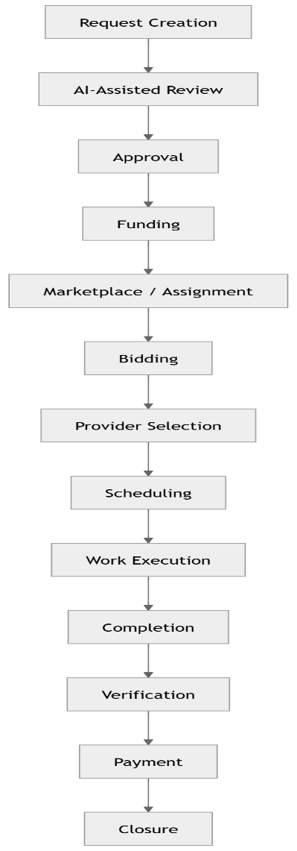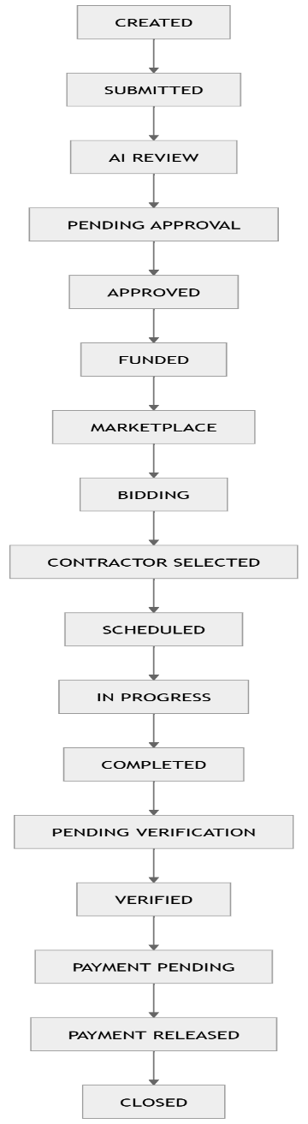

FRD — Full platform flow diagram
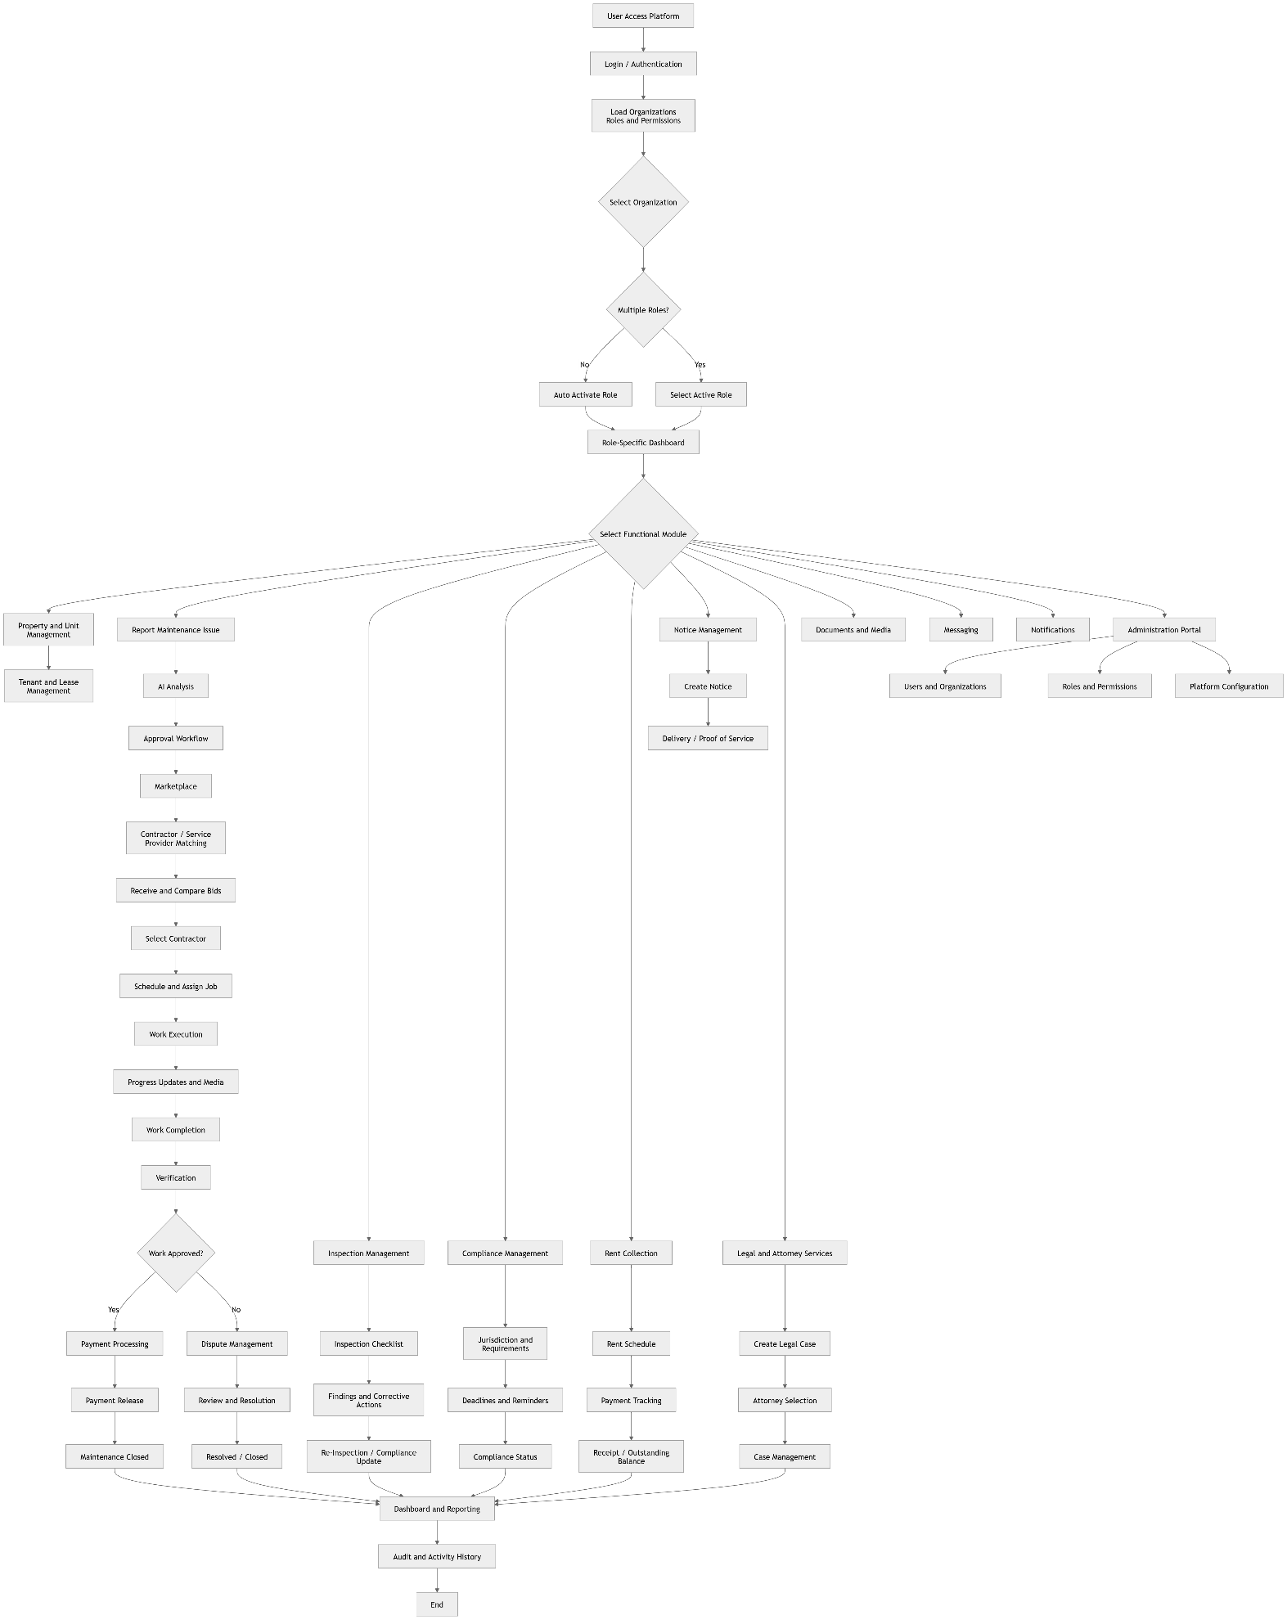
Wireframe screen titles — “Marketplace / Assignment,” “Bidding,” “Scheduling,” “Work Execution,” “Verification” — match the Proposal diagram’s box labels almost verbatim. This level of agreement is unlikely to be coincidental; the wireframes were clearly built directly against this diagram.

FLAGGED GAPS (5)
Things the FRD/Proposal call for that the current wireframe batch doesn't show.
# | ISSUE | SEVERITY | DETAIL & RECOMMENDATION
1 | No dashboard for Gig Worker / Field Worker | SHOULD ADDRESS | The FRD names this as one of 8 core roles and specifies its own dashboard content (assigned tasks, schedule, instructions, completion requirements). The wireframe's Dashboards section (02) covers only 6 roles — Tenant, Landlord, Property Manager, Contractor, Inspector, Attorney.  Ask: does Gig Worker reuse the Contractor dashboard, or does it need its own screen before this batch is signed off?
2 | Provider-side “supply” screens are missing | SHOULD ADDRESS | The wireframes only show the requester side of marketplace flows — a Property Manager reviewing bids, a client reviewing a legal case. Missing: the Contractor's own bid-submission screen, license/insurance upload, and the Attorney's opportunity review / pricing-proposal screens — all explicitly specified in the FRD.  Ask: confirm these are planned as a separate wireframe batch, not dropped from scope.
3 | No dispute or cancellation screens for maintenance | SHOULD ADDRESS | Both source diagrams define a “Work Approved? → No → Dispute Management” branch, and the FRD lists DISPUTED / CANCELLED as valid lifecycle states. The wireframe's 13-screen flow (§04) shows only the happy path to “Request Closed.”  Ask: confirm dispute UI is scheduled for a later batch.
4 | No Ratings & Performance screen | MINOR | The FRD has a full section on rating completed work, with no corresponding wireframe screen. Low urgency: the FRD's own MVP priority sequence places Ratings outside Priority 1–3, so this may simply not be due yet.  No action needed for this batch; track for a later design pass.
5 | Compliance screen shows an unexplained dollar figure | WORTH CONFIRMING | The Compliance screen (§05.3) displays “Total Due $92,500.00.” The FRD's compliance requirements cover deadlines, certifications, and re-inspection tracking only — no mention of compliance-related fees. This may be a copy from the Rent module layout rather than an intentional feature.  Ask: the designer, before this reads as a committed feature.

Not a gap: the wireframes don't include Admin Portal screens. That's expected — the Proposal scopes the Administration Portal as a separate web deliverable, outside this mobile wireframe set.
METHODOLOGY & LIMITS
WHAT WAS CHECKED  - Full paragraph and table text extracted from both .docx files  - All 7 embedded diagrams across both documents opened and read (3 shown above)  - Every wireframe section cross-referenced against its matching FRD clause | WHAT WASN'T VERIFIED  - Whether the source wireframe file has additional artboards beyond the single image reviewed  - Exact figures/labels on the wireframe — read visually, not OCR-checked  - Anything outside these three files (no design-tool source, no ticket tracker)

SOURCES REVIEWED
Proposal Document – Mobile Application.docx
FRD – Mobile Application.docx
Mobile App Wireframes (image, provided in review thread)
Prepared for internal review · not a client-facing document

